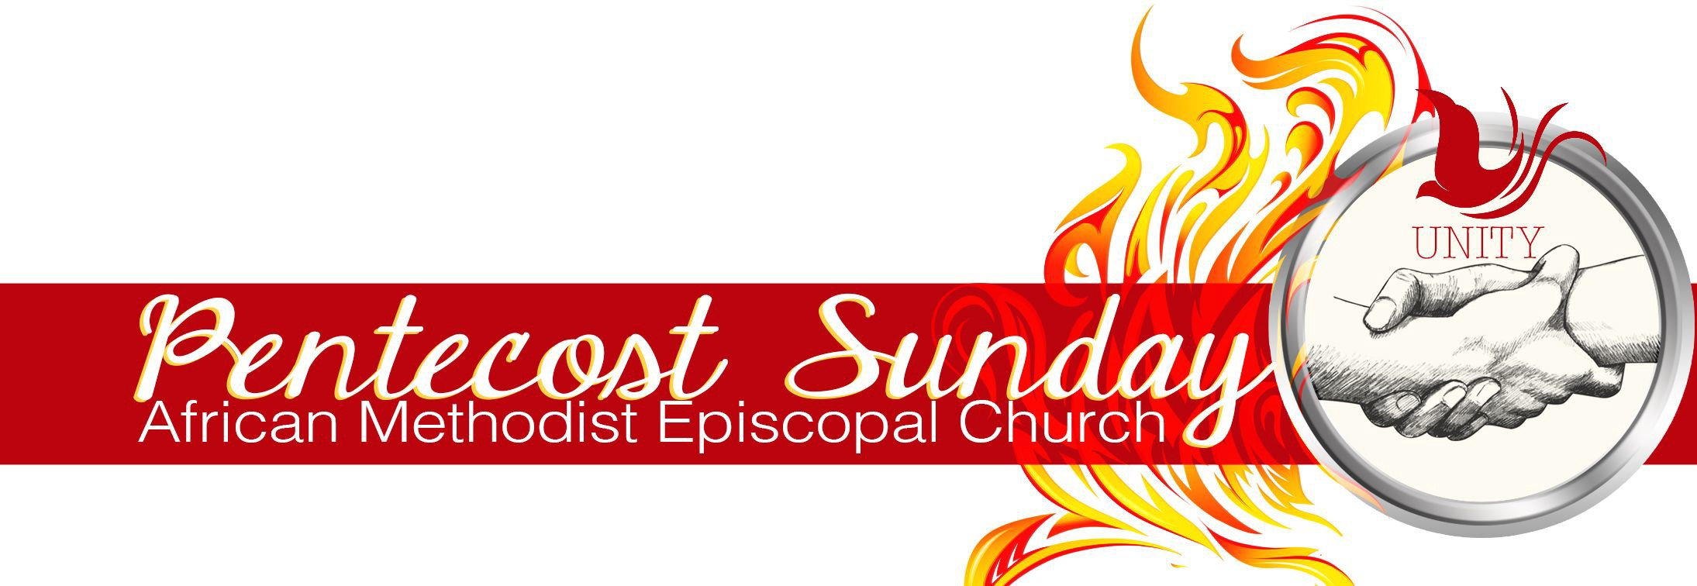

PRAYER AND RESPONSE for the PENTECOST SEASON

By: Reverend Jazmine Brooks

PRAYER: On the day of Pentecost, ALL were filled with the Holy Spirit and began to speak in their own languages. They told of God’s deeds of power. Each speaking, hearing, and understanding in their own language. May that same spirit that fell on the day of Pentecost fall fresh now, filling us now, speaking to us in our own language, so that we might hear and understand what is our call to live out God’s deeds in the world.
RESPONSE: Spirit of the living God, fall fresh on us.

PRAYER: May the power of glossolalia be coupled with the courage to speak truth to power, advocate for and alongside the most vulnerable, and declare “good news be brought to the poor, the captives be delivered, the blind be made to see, and the oppressed be made free”. May the spirit cause us to speak up and speak out for life’s sake.
RESPONSE: All power to God’s people. May the spirit of the living God fall afresh.

PRAYER: May the wind of God move us beyond the borders of geographic locations, religiosity, and class status, until the personal becomes universal and the universal is made personal. May the spirit inspire solidarity among us, so that we might find space to collectively imagine and create a world better than what we inherited and reflective of God’s ordination. Lord, let it be on earth as it is in heaven.
RESPONSE: All power to God’s people. May the spirit of the living God fall afresh.

PRAYER: May the power to call forth life amid death dealing politics and policies fall fresh on us. We call forth a spirit of mutual aid, the spirit of a communal gospel, and the Acts that hold us in love and charity with our neighbors. We call forth life by way of housing, access to clean air, food, and water, free and affordable healthcare, access to education, and fair wages.
RESPONSE: All power to God’s people. May the spirit of the living God fall afresh.

PRAYER: May the power to call forth life amid death dealing international relations fall fresh on us. We call forth justice in Columbia, in Israel, the Congo, Sudan, and all across the African diaspora. May all of God’s people hear the cries of the silenced, understand, and be set at liberty to respond. Spirit of the living God, fall fresh on us.
RESPONSE: All power to God’s people. May the spirit of the living God fall afresh.

PRAYER: May the spirit that fell on the day of Pentecost fall on us now, so that we might speak and embody God’s deeds until all of God’s children are made free.
RESPONSE: All power to God’s people. May the spirit of the living God fall afresh.

