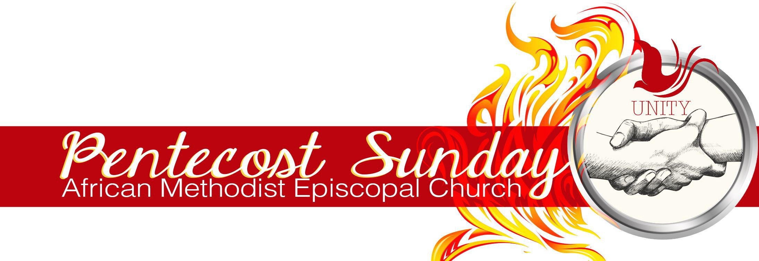

HYMN SUGGESTIONS for the PENTECOST SEASON

Joys Are Flowing Like a River | #200

O Spread the Tidings ‘Round (The Comforter Has Come) | #199 Spirit of God, Descend upon My Heart | #189
There’s a Sweet, Sweet Spirit | #196 Breathe on Me, Breath of God | #192 Let It Breathe on Me | #295
Spirit of the Living God | #619 Come Holy Ghost, Our Souls Inspire | #194

AFRICAN METHODIST EPISCOPAL CHURCH | PENTECOST HYMN SUGGESTIONS 2021

