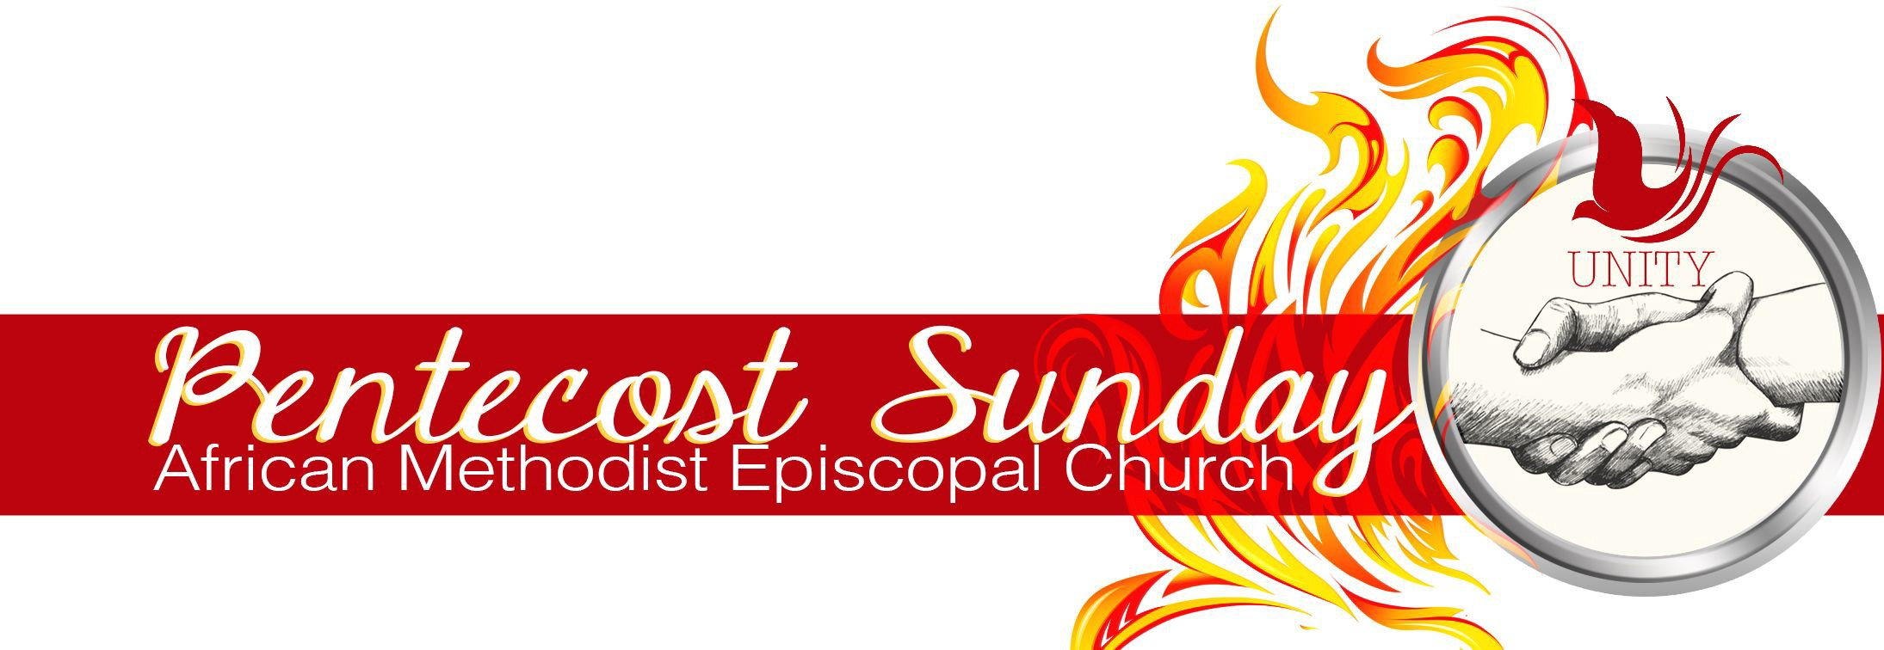
CALL TO WORSHIP for PENTECOST SUNDAY
By: Rev. Dr. Curry F. Butler

LEADER: In a social climate that does not favor our existence we gather together as our ancestors did on one accord waiting on your arrival. Come Holy Spirit Come!
RESPONSE: Bring With You Your Power!
LEADER: We invoke your presence to come and rest upon us so that we might understand one another beyond generation and gender. We are the Beloved Community!
RESPONSE: Bring With You Your Power!

LEADER: Power not only to be witnesses of your glory, but to stand strong together during a time when lady justice sometimes seems blind and those who vow to protect us are causing our blood to cry from the pavement. We need your peace!
RESPONSE: Bring With You Your Power!

LEADER: Power to speak life into our kings and queens, both young and old, letting them know that they are somebody. “We must be respected, protected, never rejected!”¹
RESPONSE: Bring With You Your Power!

LEADER: Power to be our strength during our times of weakness so that we might sing unto the Lord a new song.

RESPONSE: With uplifted voices for as long as we shall live.

ALL: Holy Spirit, you are welcome here.

1 Jordan Perrimon, “TeenSummit Program,” AnyFlip, last modified December 12, 2016, accessed April 25, 2021, http://anyflip.com/ldwl/sgkt/basic.

AFRICAN METHODIST EPISCOPAL CHURCH | PENTECOST SUNDAY 2021

